***Module (JAVASCRIPT BASIC & DOM) – 4***

***(Basic logic Question)***

1. What is JavaScript? How to use it?

JavaScript is a high-level, interpreted programming language that is primarily used to add interactivity and dynamic behavior to web pages.

***To use JavaScript:***

You can include JavaScript code directly within HTML using <script> tags.

External JavaScript files with a .js extension can be linked to HTML using the <script> tag's src attribute..

1. How many types of variables in JavaScript?

There are three types of variables in JavaScript: var, let, and const. These keywords are used to declare variables.

***var***: Function-scoped or globally scoped variable. It is outdated JavaScript.

***let***: Block-scoped variable, introduced in ECMAScript 6 (ES6). It has a limited scope within the block, statement, or expression where it is used.

***const***: Also introduced in ES6, it declares a constant variable it is not change.

1. Define Data Types in JavaScript?

JavaScript has several data types, which can be categorized as primitive and non-primitive.

***Primitive data types:***

***String***: Textual data.

***Number***: Numeric data, including integers and floating-point numbers.

***Boolean***: Represents either true or false.

***Undefined***: Default value of variables that have not been assigned a value.

***Null***: Represents the intentional absence of any object value.

***Non-primitive data type:***

***Object***: A collection of key-value pairs, often used to represent complex entities.

***Array*** : Is a collection of Data type. []

***Date*** : new Date()...

1. Write a mul function which will work properly when invoked with the following syntax:

console.log(mul(2)(3)); // Output: 6…

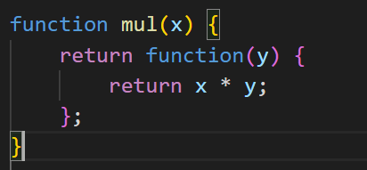

1. What is the difference between undefined and undeclared in JavaScript?

Undefined: A variable is declared but has not been assigned a value. It is a special value that represents the absence of a value or an uninitialized variable.

Undeclared: A variable that has not been declared using var, let, or const. Accessing an undeclared variable usually results…

1. Using console.log() print out the following statement:

"The quote 'There is no exercise better for the heart than reaching down and lifting people up.' by John Holmes teaches us to help one another."

Using console.log() to print the quote by Mother Teresa:

Ex:-

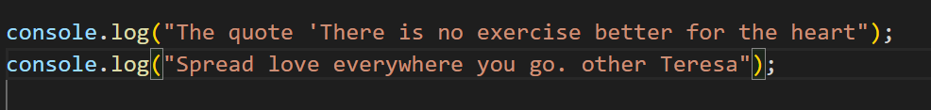

1. Check if typeof '10' is exactly equal to 10. If not, make it exactly equal?

* This is Check typeof 10 code….and exactly to 10.perfect code..

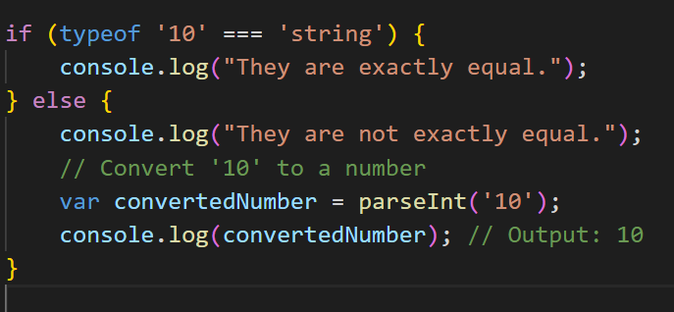

1. Write a JavaScript program to find the area of a triangle?

Maths Formula (a+b+c)/2; Math. sqrt(p*((p-a)*(p-b)*(p-c))); Code..

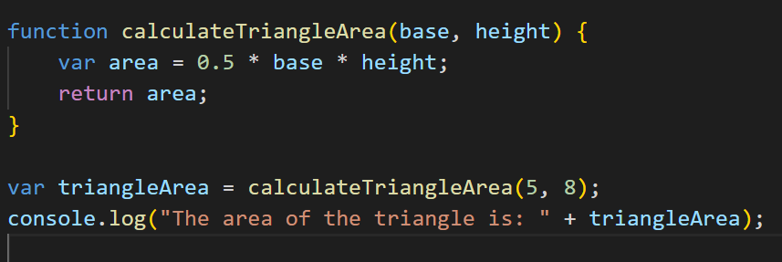

1. Write a JavaScript program to calculate days left until next Christmas?

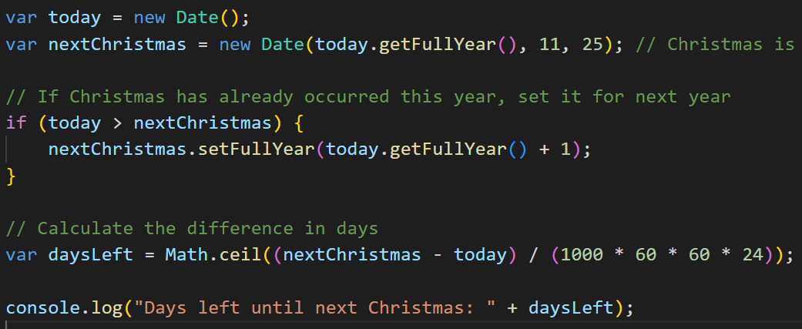

1. **What is a Condition Statement?**

A condition statement in programming is a construct that allows you to execute different blocks of code based on whether a specified condition evaluates to true or false. In JavaScript, common condition statements include if, else if, and else.

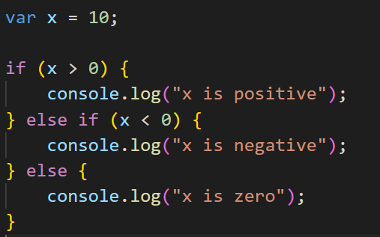

1. Find the circumference of a Rectangle with the formula C = 2 * (length + width) ?

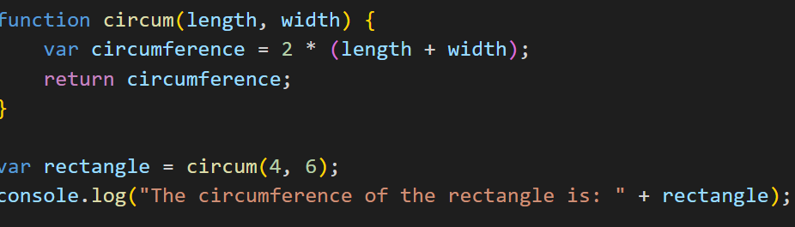

1. Write a program to convert years into days and days into years:

This is code for convert year to days…

1. Convert temperature Fahrenheit to Celsius with conditional logic:

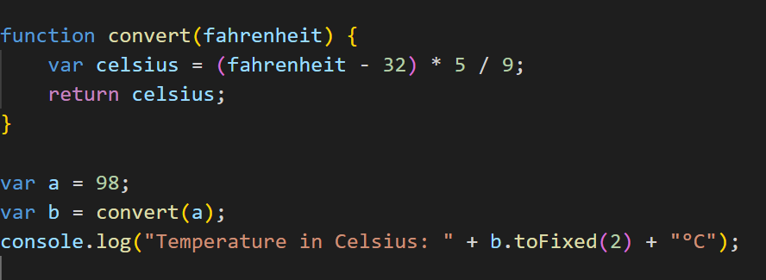

1. Get the extension of a filename:

This is use function filename and return filename…

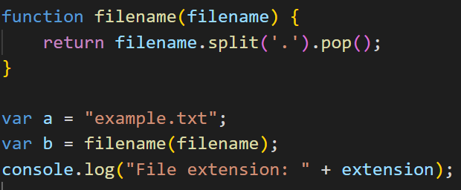

1. Result of the expression (5 > 3 && 2 < 4):

The result is true because both conditions are true.

1. Result of the expression (true && 1 && "hello"):

The result is "hello" because all conditions are truthy, and the last truthy value is returned.

1. Result of the expression true && false || false && true:

The result is false because the expression is evaluated as (true && false) || (false && true).

1. What is a Loop and Switch Case in JavaScript?

Loop: A loop is a programming construct that allows you to repeat a set of instructions until a certain condition is met.

Switch Case: switch is a control flow statement used in JavaScript to perform different actions based on different conditions. It is a cleaner way to write multiple if-else statements.

1. What is the use of is NaN function?

The isNaN function in JavaScript is used to determine whether a value is NaN (Not-a-Number). It returns true if the value is NaN, and false otherwise. It's often used to check..

1. Difference between && and || in JavaScript:

&& (Logical AND): Returns true if both operands are true.

|| (Logical OR): Returns true if at least one of the operands is true.

1. What is the use of void(0)?

void(0) is often used in JavaScript to create an expression that evaluates to undefined.

It is commonly used as the href attribute in anchor tags (<a> elements)..

1. Check if a Number Is Positive or Negative in JavaScript.

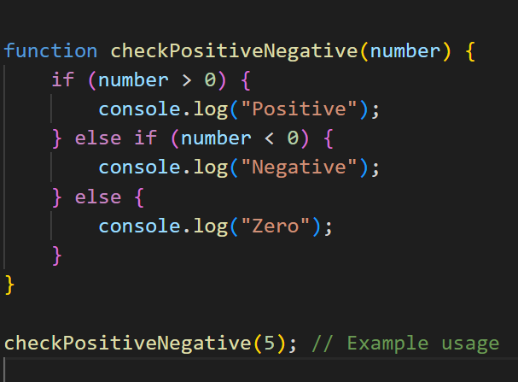

1. Check if a Character Is a Vowel or Not:

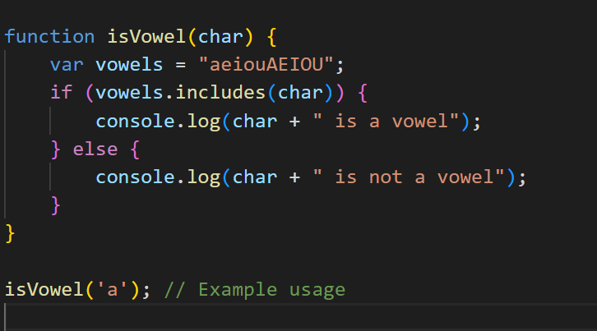

1. Check whether a number is negative, positive, or zero:

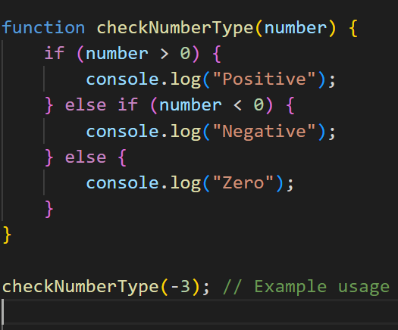

1. Check if a number is even or odd using ternary operator in JS:

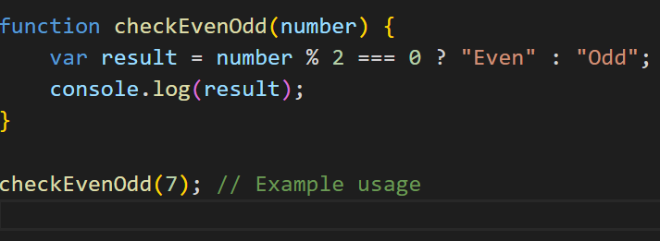

1. Find the maximum number among 3 numbers using ternary operator in JS:

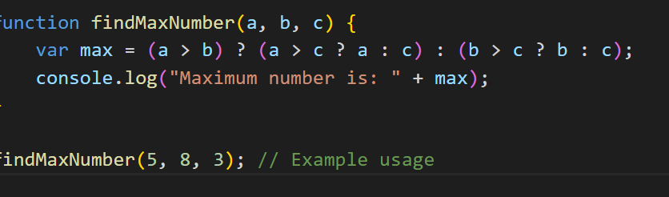

1. Find the minimum number among 3 numbers using ternary operator in JS:

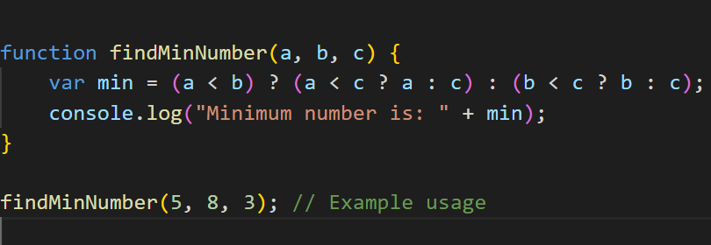

1. Find the largest of three numbers in JS:

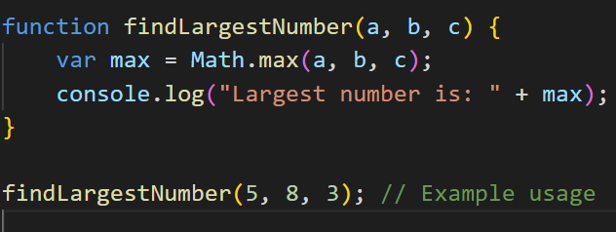

29. Switch case to show:

i. Monday to Sunday using switch case in JS.

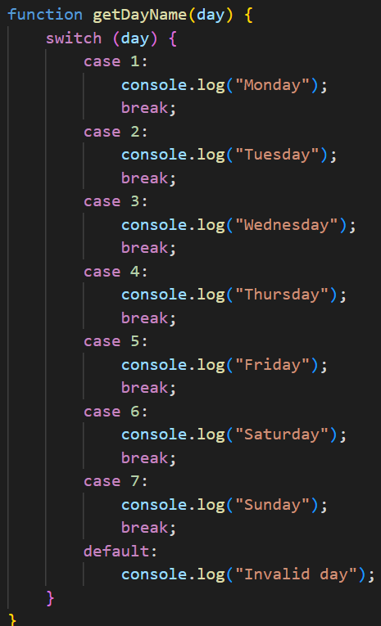

1. What are the looping structures in JavaScript? Any one Example?

for loop:

while loop:

1. Write a print 972 to 897 using for loop in JS:

1. Write to print factorial of given number:

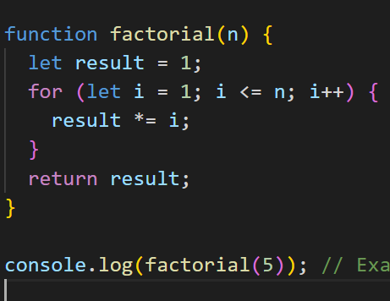

1. Write to print Fibonacci series up to given numbers:

1. Write to print number in reverse order e.g.: number = 64728 ---> reverse = 82746 in JS:

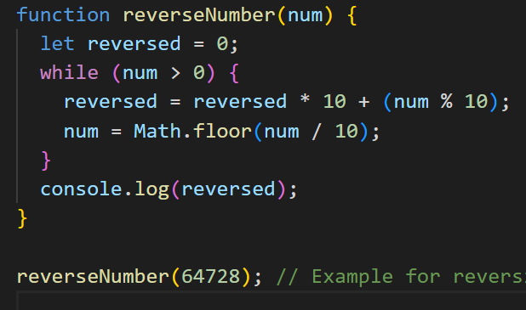

1. Write a program to make a summation of given number (E.g., 1523 Ans: - 11) in JS:

1. Write a program to make a summation of the first and last digit. (E.g., 1234 Ans: - 5) in JS:-

1. Use console.log() and escape characters to print the following pattern in JS:-

1. Use pattern in console.log in JS?

1.Pattern:-

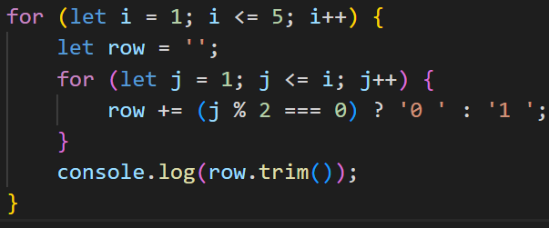

2.Pattern:-

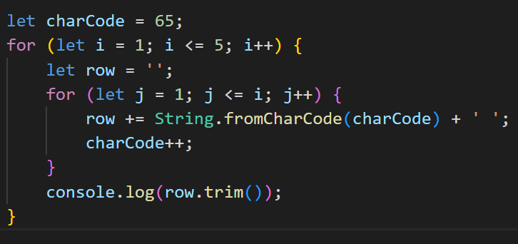

3.Pattern:-

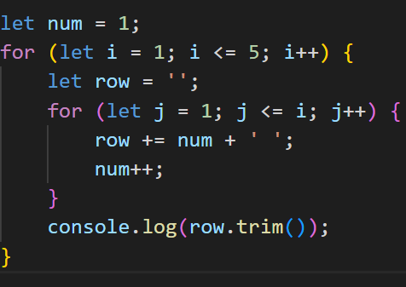

4.pattern:-

1. Accept 3 numbers from user using while loop and check each numbers palindrome?

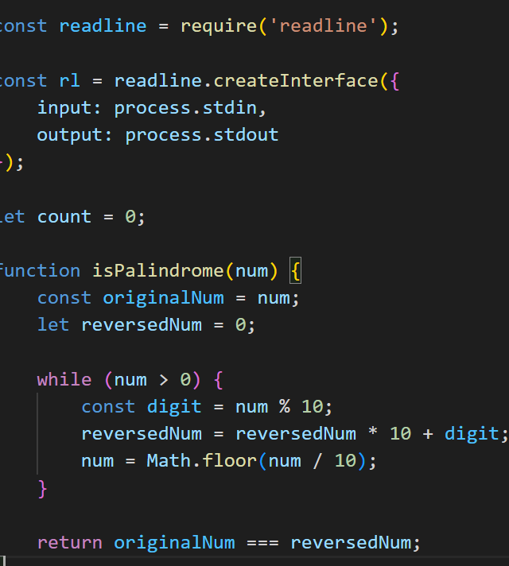

***(Array and object Question)***

1. Write a JavaScript Program to display the current day and time in the following format.

Sample Output: Today is Friday. Current Time is 12 PM: 12 : 22 2 ?

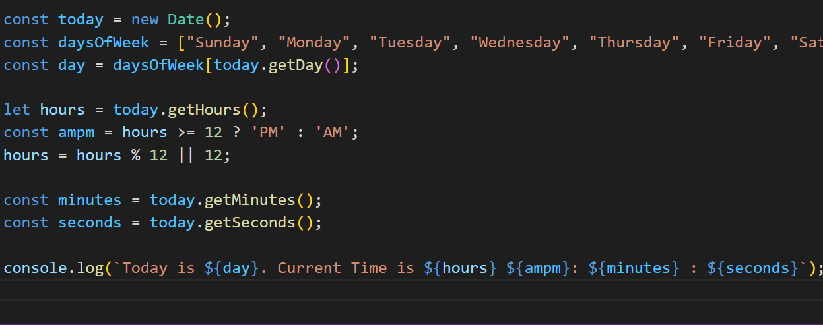

1. Write a JavaScript program to get the current date?

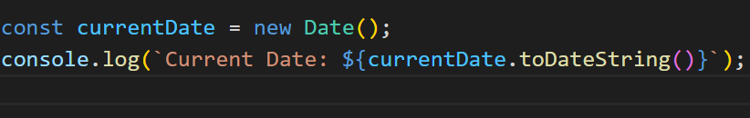

1. Write a JavaScript program to compare two objects?

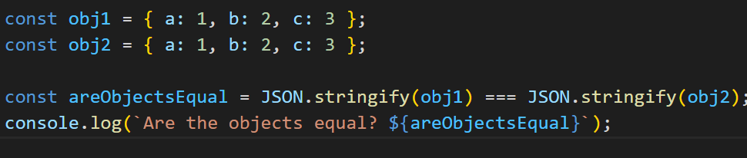

1. Write a JavaScript program to convert an array of objects into CSV string?

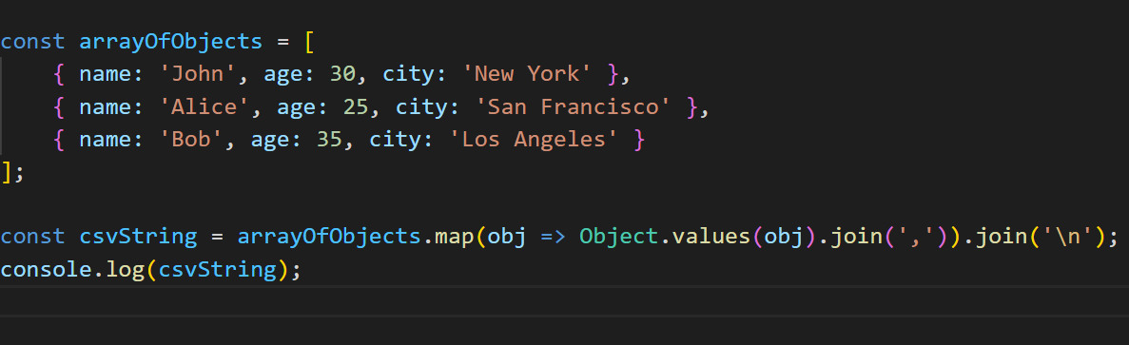

1. Write a JavaScript program to capitalize first letter of a string?

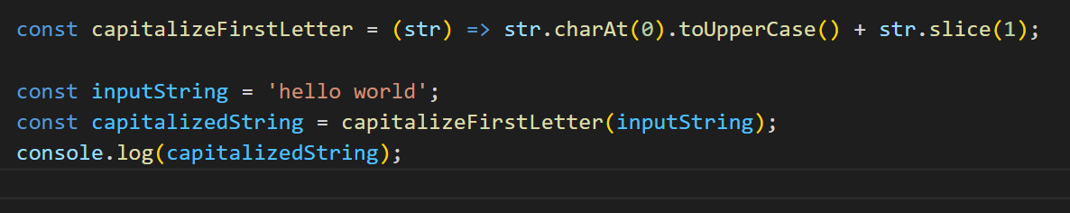

1. Write a JavaScript program to determine if a variable is array?

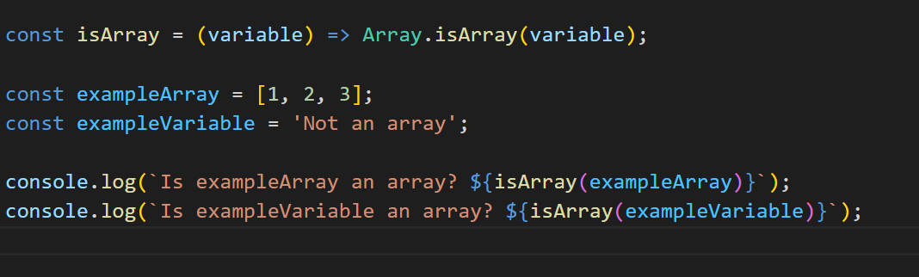

1. Write a JavaScript program to clone an array?

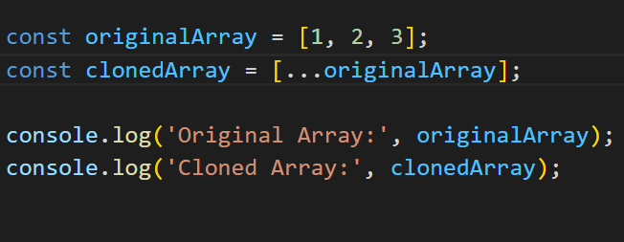

1. What is the drawback of declaring methods directly in JavaScript objects?

The main drawback is that methods declared directly in JavaScript objects are duplicated for each instance of the object, which consumes more memory. If the method is the same for all instances, it's more memory-efficient to declare it in the object's prototype.

1. Print the length of the string on the browser console:

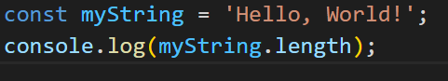

1. Change all string characters to capital letters:

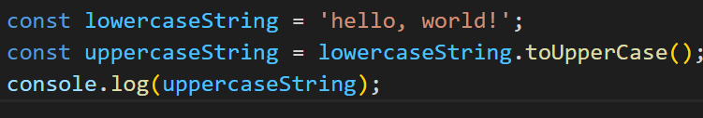

1. Drawback of declaring methods directly in JavaScript objects:

As mentioned earlier, the main drawback is that methods declared directly in JavaScript objects are duplicated for each instance of the object, which can lead to increased memory consumption. This is not memory-efficient, especially if the methods are the same for all instances. Declaring methods in the prototype allows them to be shared among all instances of the object, reducing memory usage.

1. JavaScript program to get the current date in different formats:

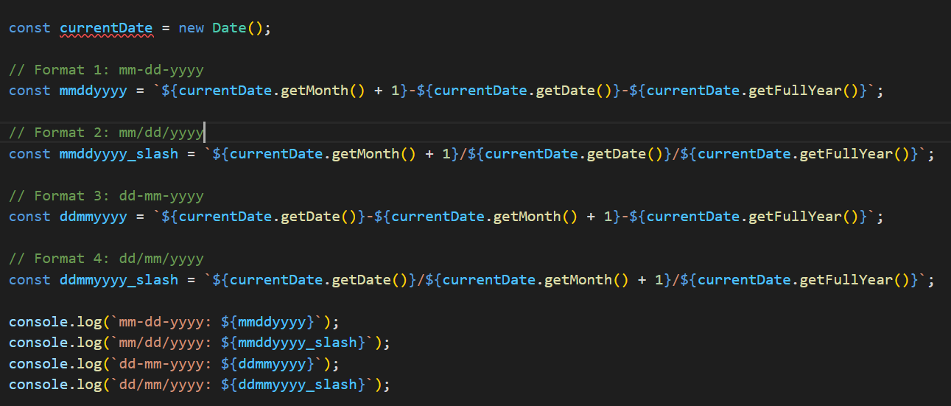

1. Use indexOf to determine the position of the first occurrence of 'a' in '30 Days Of JavaScript':

1. Use lastIndexOf to determine the position of the last occurrence of 'a' in '30 Days Of JavaScript':

1. Form Validation in JavaScript:

1. Form Validation for Email, Number, and Password in JavaScript:

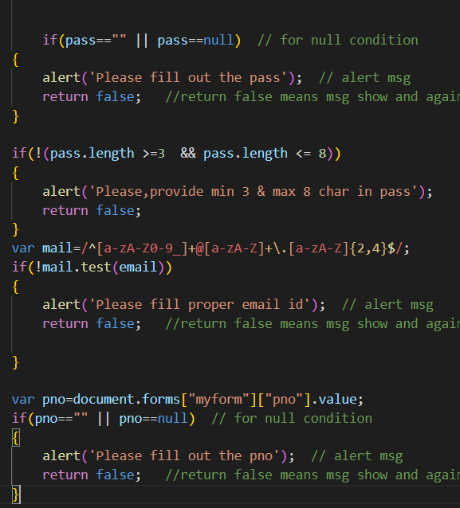

1. Dynamic Form Validation in JS?

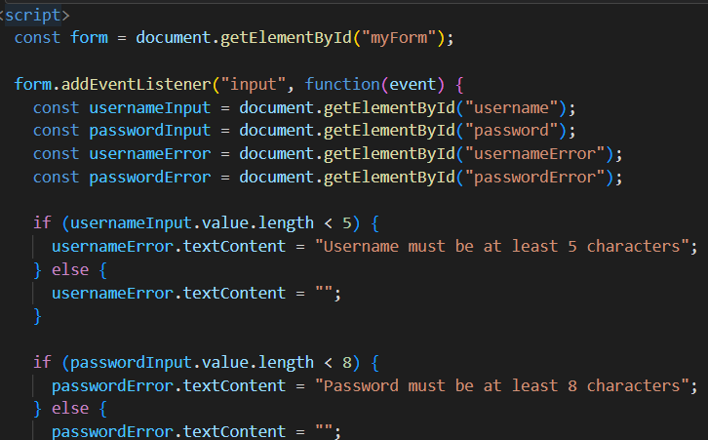

1. How many types of JS events? How to use them?

***Mouse events*** (click, mouseover, mouseout, etc.)

***Keyboard even***ts (keydown, keyup, keypress)

***Form events*** (submit, change, input)

***Document events*** (DOMContentLoaded, load, unload)

1. What is BOM vs DOM in JS?

***DOM***: It represents the structure of a document as a tree of objects. The DOM is used to interact with HTML or XML documents.

***BOM***: It represents the browser as an object. It includes objects like window, navigator, location, screen, and document (which is part of the DOM).

1. Array vs Object differences in JS?

Arrays are ordered collections of values, accessed by numerical indices

Objects are unordered collections of key-value pairs.

1. Split the string into an array using split() Method?

The split() method in JavaScript is used to split a string into an array of substrings based on a specified delimiter.

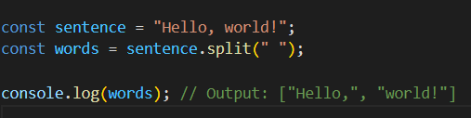

1. Check if the string contains a word "Script" using includes() method?

The includes() method checks if a string contains a specific substring and returns a boolean value.

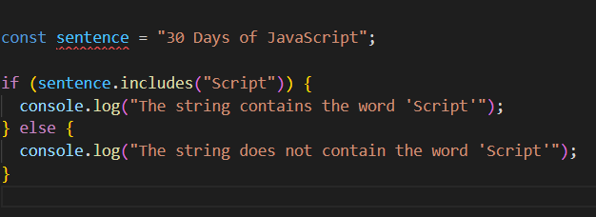

1. Change all the string characters to lowercase letters using toLowerCase() method.

The toLowerCase() method in JavaScript is used to convert all characters in a string to lowercase

1. What is the character at index 15 in the '30 Days of JavaScript' string? Use charAt() method.

The charAt() method in JavaScript is used to get the character at a specified index in a string

1. Copy one string to another string in JS?

1. Find the length of a string without using the library function?

* What is JavaScript?

JavaScript is a high-level, interpreted programming language that is widely used for creating dynamic content on the web. It is primarily known for adding interactivity to web pages.

* What is the use of isNaN function?

The isNaN function in JavaScript is used to check whether a value is NaN (Not-a-Number) or not. It returns true.

***isNaN(123); // false***

***isNaN('Hello'); // true***

* What is negative Infinity?

Negative Infinity is a special value in JavaScript representing negative infinity. It is the result of dividing a negative number by zero or any mathematical operation that results in an infinitely negative value.

* Which company developed JavaScript?

JavaScript was developed by Netscape Communications Corporation, with Brendan Eich creating the language in 1995.

* What are undeclared and undefined variables?

*Undeclared variables*: Variables that have been neither declared using the var, let, or const keyword nor defined in the current scope. Accessing an undeclared variable will result in a ReferenceError.

*Undefined variables*: Variables that have been declared but not assigned a value are considered undefined.

* Write the code for adding new elements dynamically?

* What is the difference between ViewState and SessionState?

ViewState: ViewState is used to store the state of the page and its controls between postbacks. It is stored as a hidden field on the page.

SessionState: SessionState is used to store user-specific information that persists across multiple requests.

* What is === operator?

The === operator in JavaScript is the strict equality operator. It checks both value and type equality, unlike the loose equality operator (==),

* How can the style/class of an element be changed?

* How to read and write a file using JavaScript?

In a web browser environment, JavaScript has limited access to the file system due to security reasons. However, you can read files using the FileReader API or write data to a file using server-side technologies like Node.js.

* What are all the looping structures in JavaScript?

JavaScript supports several looping structures:

*for loop*

*while loop*

*do-while loop*

*for...in loop* (used for iterating over object properties)

*for...of loop* (used for iterating over iterable objects like arrays)

* How can you convert the string of any base to an integer in JavaScript?

You can use the parseInt function to convert..

* What is the function of the delete operator?

The delete operator in JavaScript is used to delete an object property or an element at a specified index in an array.

It does not delete variables or functions.

* What are all the types of Pop up boxes available in JavaScript?

JavaScript provides three types of pop-up boxes:

alert() - displays an alert dialog box.

confirm() - displays a dialog box with OK and Cancel buttons.

prompt() - displays a dialog box with an input field

* What is the use of Void (0)?

void(0) is often used in JavaScript to generate an undefined value. It's commonly used in href attributes to prevent the page from navigating..

* How can a page be forced to load another page in JavaScript?

You can use the window.location object to navigate to another page…

* What are the disadvantages of using innerHTML in JavaScript?

Using innerHTML to manipulate or append content can have security implications, as it may execute scripts included in the HTML string. It's also less efficient than alternative methods like createElement and appendChild because it requires the browser to parse and re-render the entire HTML content of an element.

----------------------------***Complete***---------------------------